**BitBucket Server Integration**

**Jenkins Plugins**

Install BitBucket Server Integration

**Configure the plugin**

==========================

1. [Add Bitbucket Server instance details](https://plugins.jenkins.io/atlassian-bitbucket-server-integration/#plugin-content-add-bitbucket-server-instance-details).
2. Configure PAT/credentials in Jenkins

**Add Bitbucket Server instance details**

**=====================================**

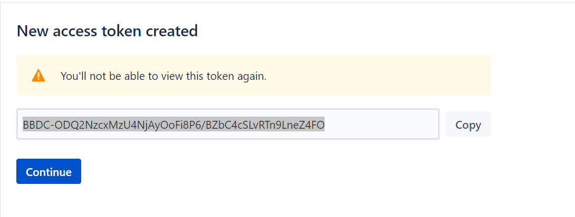

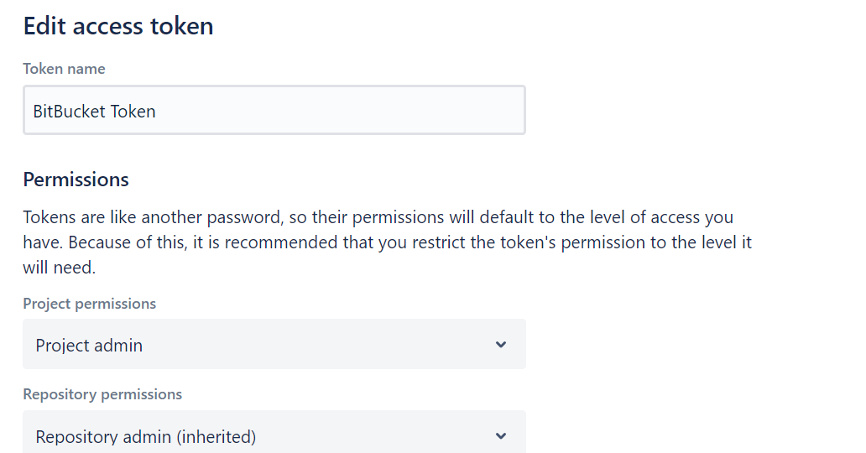

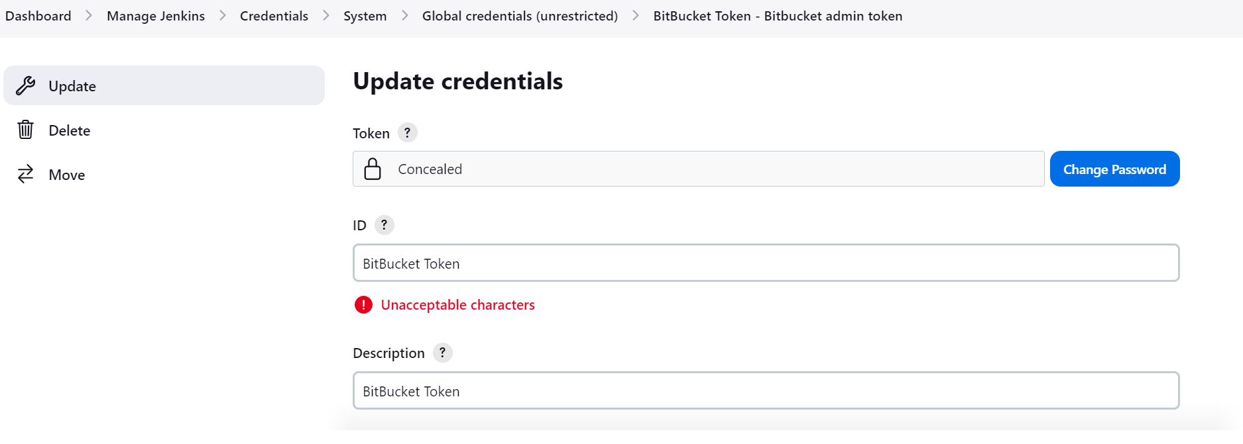



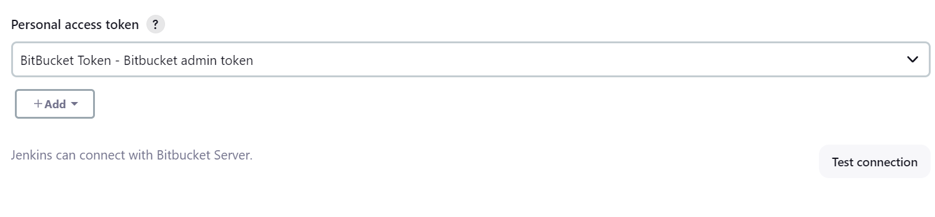

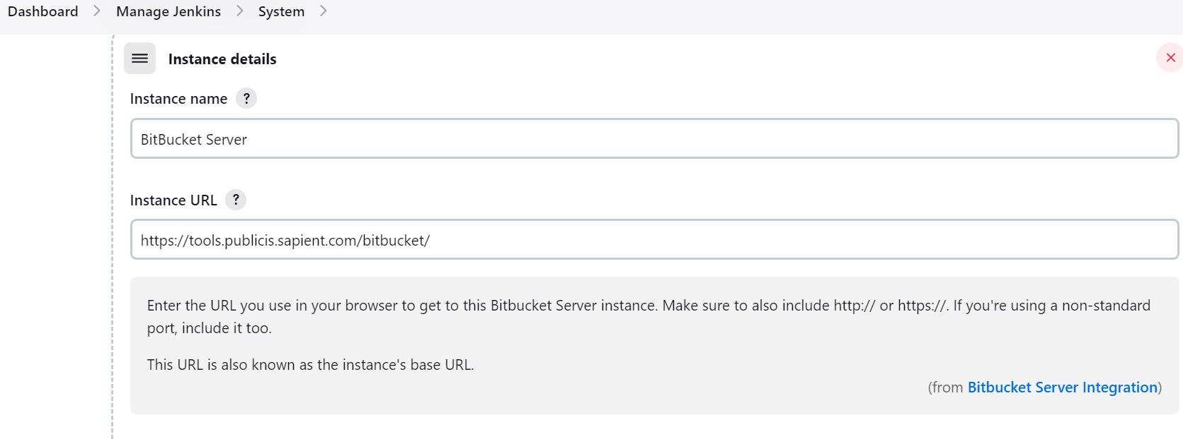

SetUp Username/Password credentials – Password can be a BitBucket PAT

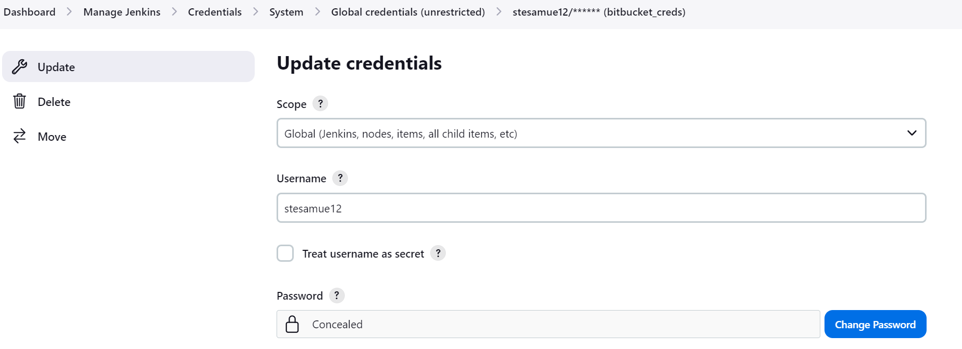 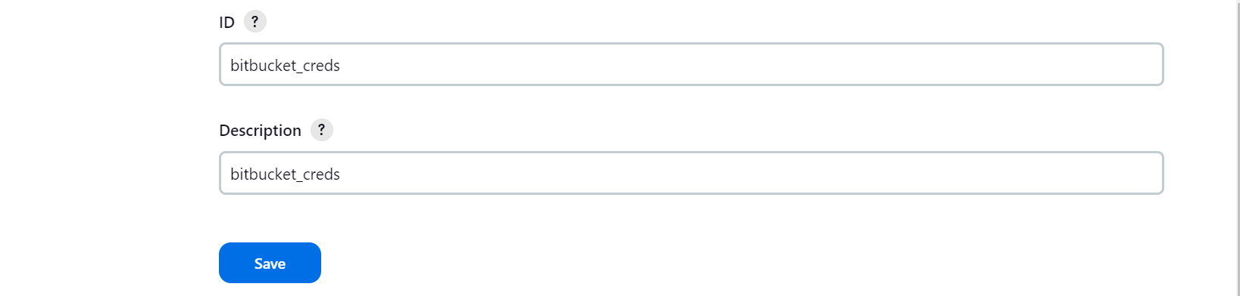

Configure Multibranch Pipeline

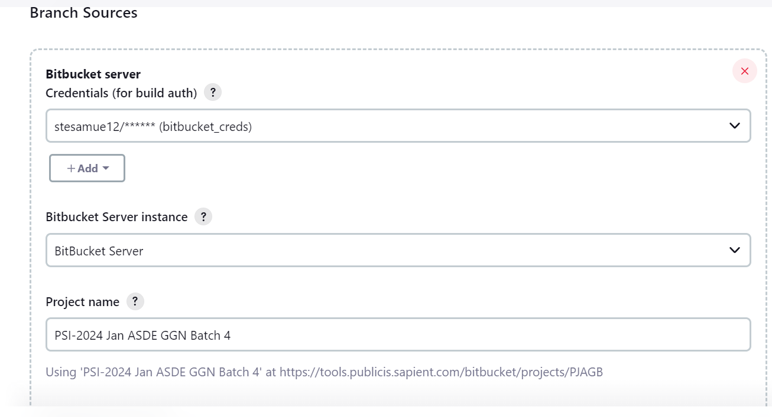

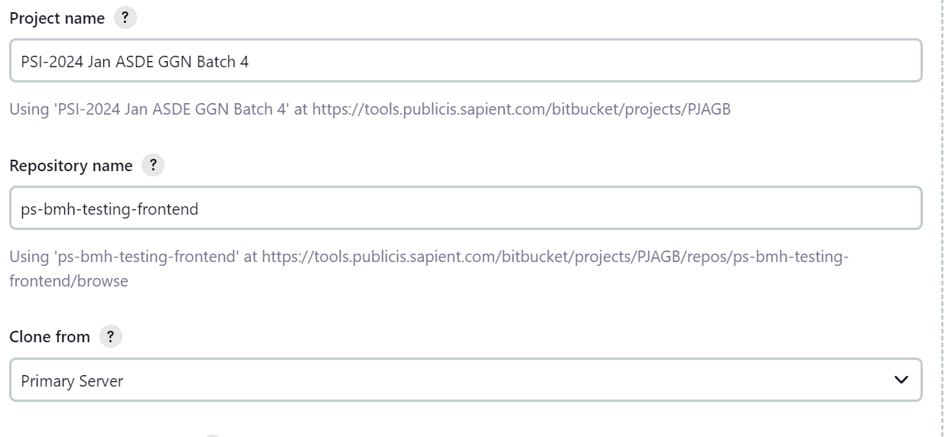

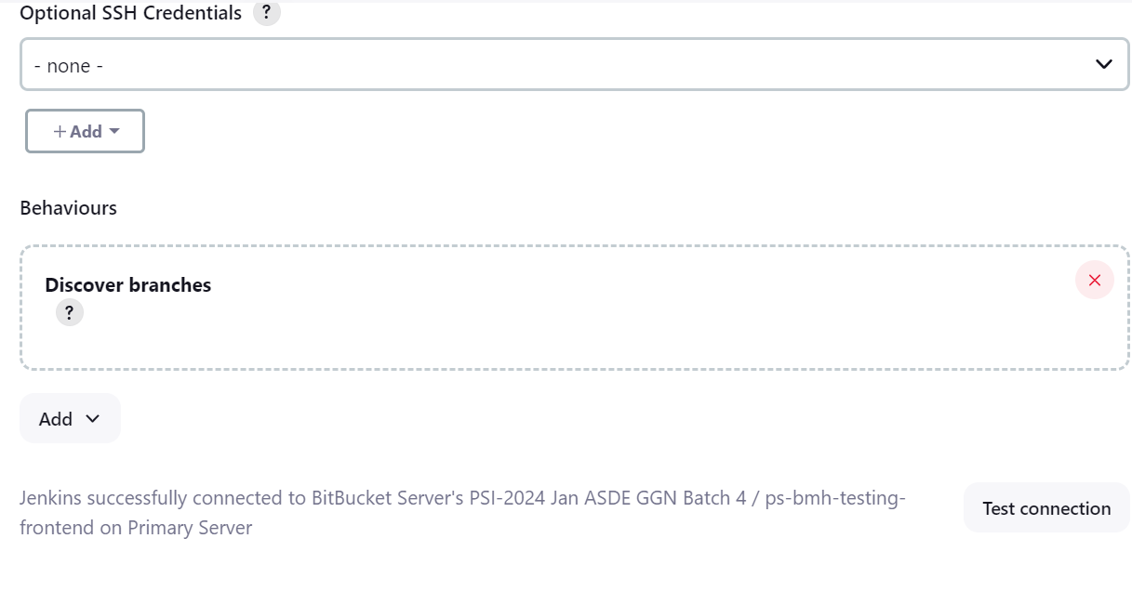

Add Jenkinsfile to root of project

